

Safety Bay Senior High School

Chemistry Unit 2

**Test #4:**

**Intermolecular Forces**

**Solutions**

**NAME: ______________________________________**

**DATE: ______________________________________**

|  |  |
| --- | --- |
| **Section** | **Mark** |
| Multiple Choice | / 10 |
| Short Answer | / 45 |
| **Total** | **/ 55** |

**Section 1: Multiple Choice (10 marks)**

1. Which of the following correctly arranges the compounds in order of **increasing** polarity of bond?
   1. F2 CℓF BrF IF
   2. IF BrF CℓF F2
   3. CℓF BrF IF F2
   4. F2 IF BrF CℓF
2. Which of the molecules is non-polar but contains polar covalent bonds?
   1. Oxygen, O2
   2. Sulfur dioxide, SO2
   3. Tetrachloromethane, CCℓ4
   4. Ammonia, NH3
3. For the substances C (graphite), O2, C3H8 and C2H5OH, which of the following represents them in order of **increasing** melting point?
   1. O2­ C3H8 C2H5OH C
   2. C3H8 O2 C2H5OH C
   3. O2 C C3H8 C2H5OH
   4. O2 C C2H5OH C3H8
4. In general, what can be said about the surface tension and vapour pressure of substances which have particularly **weak** intermolecular forces?
   1. Surface tension: High Vapour pressure: Low
   2. Surface tension: High Vapour pressure: High
   3. Surface tension: Low Vapour pressure: Low
   4. Surface tension: Low Vapour pressure: High
5. Which type of bonding is **NOT** present in solid hydrogen chloride (HCℓ)?
   1. Covalent
   2. Dipole-dipole
   3. Dispersion force
   4. Hydrogen bonding
6. The boiling point of a family of trihalomethanes (CHX3) are listed below:

Tetrafluoromethane CHF3 -89 °C

Tetrachloromethane CHCℓ3 61 °C

Tetrabromomethane CHBr3 150 °C

Tetraiodomethane CHI3 330 °C

The increase in boiling points moving down the list is due to an increase in the strength of:

* 1. Covalent bonding
  2. Dispersion forces
  3. Dipole-dipole bonding
  4. Hydrogen bonding

The next two questions refer to the following graph showing the solubility of two substances over a range of temperatures.

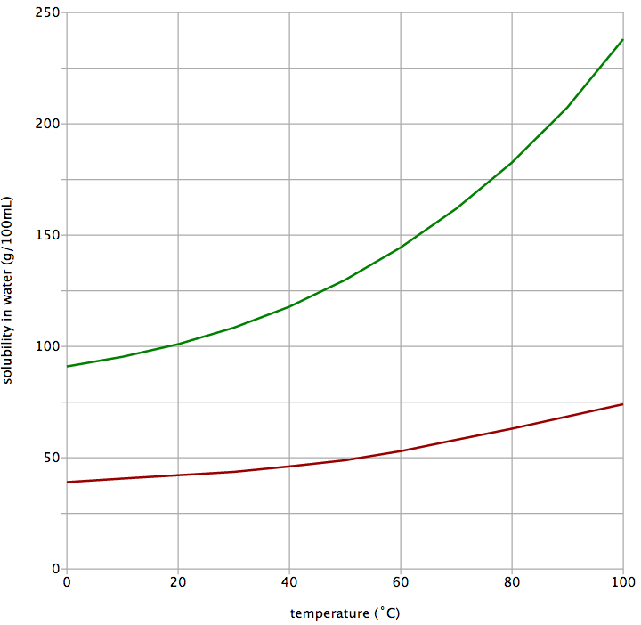

III

II

I

Copper(II) sulfate

Potassium nitrate

1. If you initially had 50 g of potassium nitrate dissolved in 300 mL of water at 20 °C, how much **additional** potassium nitrate would you be able to dissolve in this solution?
   1. 50 g

At 200C 100 g dissolved in 100mL

At 200C 300 mL can dissolve 300 g solute.

50 g already dissolved. So balance = 300- 50= 250g

Another 250 g can be dissolved

* 1. 100 g
  2. 250 g
  3. 300 g

1. Which point of the graph represents a supersaturated solution of copper(II) sulfate??
   1. Point I
   2. Point II
   3. Point III
   4. This cannot be determined without knowing the volume of water
2. The concentration of sodium hypochlorite, NaCℓO, in White Cling hospital-grade disinfectant is 52.5 g L-1. A company wished to produce 500 two-litre bottles of the disinfectant.

Which of the following formulas correctly calculates the mass of sodium hypochlorite needed by the company?

1. Consider the following TLC plate of compounds X, Y and Z developed using a non-polar mobile phase on a polar stationary phase.

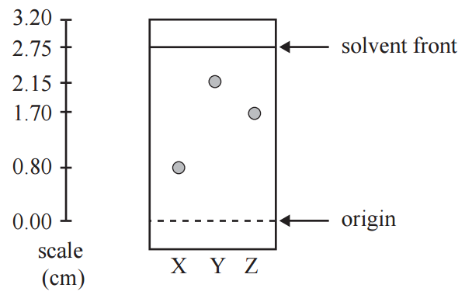

The Rf value of the most polar component in this TLC separation is:

* 1. 0.29
  2. 0.78
  3. 0.80
  4. 2.15

Most polar compound will spend longer of the stationary phase (i.e. not move).

Rf = 0.80 / 2.75 = 0.29

**Section 2: Short Answer (50 marks)**

For each of the species listed below:

* draw the structural formula, representing **all** valence shell electron pairs as : or as – (3 marks)
* draw **and** name the shape of the molecule (3 marks)
* state the polarity of the molecule (3 marks)

|  |  |  |  |  |
| --- | --- | --- | --- | --- |
| **Species** | **Structure (showing all valence shell electrons)** | **Drawing**  **of shape** | **Name**  **of shape** | **Polarity of  molecule**  (polar or  non-polar) |
| Carbon disulfide  (CS2) |  | **S = C = S** | **Linear** | **Non-polar** |
| Phosphorus tribromide  (PBr3) |  |  | **Pyramidal** | **Polar** |
| Difluoromethane  (CH2F2) |  |  | **Tetrahedral** | **Polar** |

|  |  |
| --- | --- |
| **Answer** | **Cumulative marks** |
| Structures (including valence electrons) | 3 x 1.0 |
| Drawings of shapes | 3 x 0.5 |
| Names of shapes | 3 x 0.5 |
| Polarity of molecules | 3 x 1.0 |
|  | **Total: 9 marks** |

Compare the vapour pressure and density of liquid water to the other named substances. Justify the reasoning behind your prediction, using diagrams where appropriate.

1. Compared the pentane (C5H12), the **vapour pressure** of liquid water is: (3 marks)

higher equal **lower**

**Explanation:**   
***The hydrogen bonding in water is much stronger than the dispersion forces in pentane. As a result, at a given temperature there will be less evaporated water than evaporated pentane, resulting in less gas pressure from the evaporated water molecules.***

|  |  |
| --- | --- |
| **Answer** | **Cumulative marks** |
| Lower | 1 |
| Recognises there is a difference in strength of bonding  (hydrogen bonding vs dispersion forces) | 1 |
| Shows understanding between vapour pressure and IMF | 1 |
|  | **Total: 3 marks** |

1. Compared the solid water (ice), the **density** of liquid water is: (4 marks)

higher equal lower

***Liquid water and solid water both have hydrogen bonding. In solid ice this hydrogen bonding causes particles to arrange in a way which maximises this bonding (see diagram). This configuration places molecules further apart, resulting in the solid having lower density than the liquid***

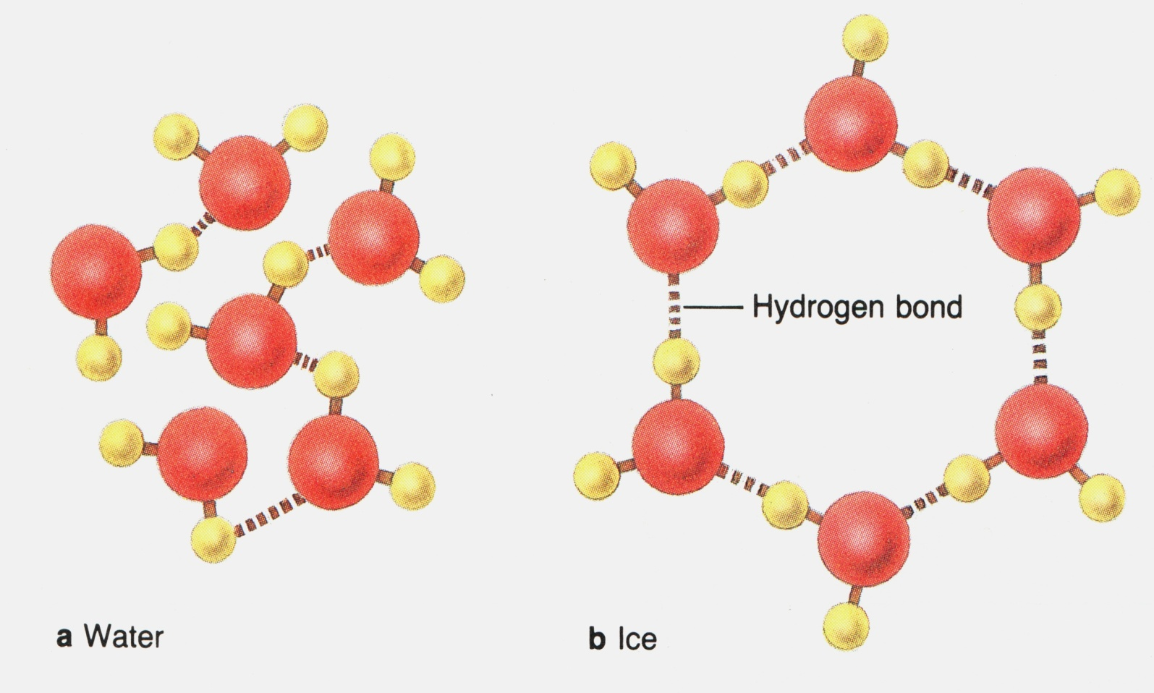

|  |  |
| --- | --- |
| **Answer** | **Cumulative marks** |
| Higher | 1 |
| Recognises that both substances have hydrogen bonds | 1 |
| Recognises that the *arrangement* of hydrogen bonds in solid ice results in lower density | 1 |
| Appropriate diagram | 1 |
|  | **Total: 4 marks** |

Formaldehyde is a toxic chemical used in the production of resins. It has the molecular formula of CH2O. The structure of formaldehyde is shown below:

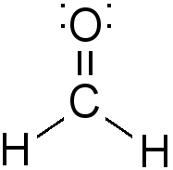

1. On the above diagram, show the ‘lone pairs’ of electrons possessed by this molecule. (1 mark)

|  |  |
| --- | --- |
| **Answer** | **Cumulative marks** |
| Includes 2 lone pairs around oxygen atom | 1 mark |
|  | **Total: 1 mark** |

1. Explain why formaldehyde has the trigonal planar shape represented in the image above.

(2 marks)

|  |  |
| --- | --- |
| **Answer** | **Cumulative marks** |
| There are three negative regions of electrons surrounding C atom | 1 mark |
| This position minimises **repulsion** between each bonding group | 1 mark |
|  | **Total: 2 marks** |

1. Formaldehyde is described as a ‘polar molecule’. Explain why this is so. (3 marks)

|  |  |
| --- | --- |
| **Answer** | **Cumulative marks** |
| Formaldehyde has polar bonds (due to differences in electronegativity between atoms) | 1 mark |
| These bonds are not symmetrical… | 1 mark |
| …resulting in the oxygen side being δ- and the other side δ+. | 1 mark |
|  | **Total: 3 marks** |

1. Salts such as sodium chloride dissolve in polar solvents like formaldehyde. Name the type of attractive force that allows sodium chloride to dissolve in formaldehyde. (1 mark)

|  |  |
| --- | --- |
| **Answer** | **Cumulative marks** |
| Ion-dipole forces | 1 mark |
|  | **Total: 1 mark** |

For each of the following molecule pairs:

1. Circle the molecule with the highest boiling point
2. Give a brief explanation for your choice
3. carbon dioxide (CO2) OR sulfur dioxide (SO2) (3 marks)

|  |  |
| --- | --- |
| **Answer** | **Cumulative marks** |
| Sulfur dioxide | 1 |
| SO2 is bent, CO2 is linear | 1 |
| SO2 will have dipole-dipole forces, which are stronger than the dispersion forces in CO2 | 1 |
|  | **Total: 3 marks** |

1. bromine (Br2) OR iodine (I2) (3 marks)

|  |  |
| --- | --- |
| **Answer** | **Cumulative marks** |
| Iodine | 1 |
| Iodine has stronger dispersion forces… | 1 |
| …due to having more electrons / greater molecular weight | 1 |
|  | **Total: 3 marks** |

Paracetamol is a commonly used painkiller. The partial equation below shows one method of preparing paracetamol.

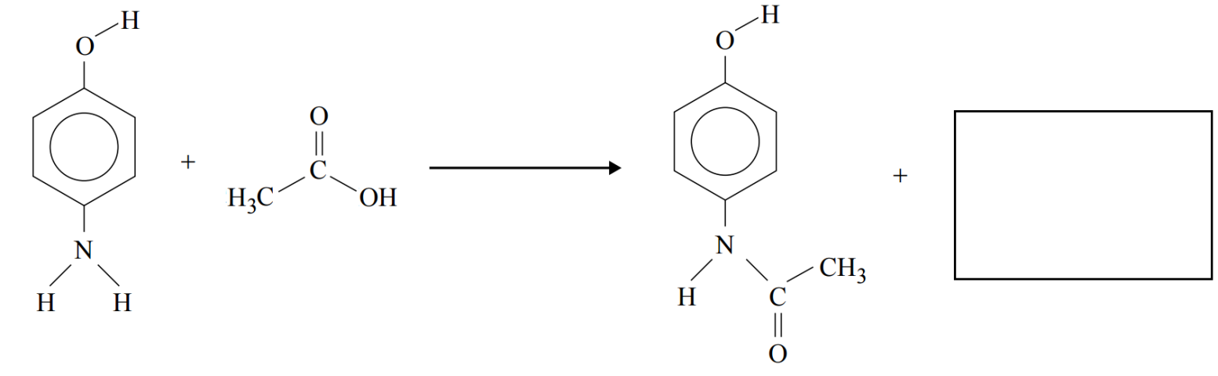4-aminophenol ethanoic acid paracetamol

1. Complete the equation below by showing the formula or structure of the other substance formed during this reaction. (1 mark)

|  |  |
| --- | --- |
| **Answer** | **Cumulative marks** |
| Water | 1 |
|  | **Total: 1 mark** |

1. Explain in terms of intermolecular forces, whether you would expect paracetamol to be soluble in water. Include a diagram showing interactions between paracetamol and water molecules. (4 marks)

|  |  |
| --- | --- |
| **Answer** | **Cumulative marks** |
| For substances to dissolve there needs to be strong interaction between the solute and the solvent | 1 |
| In this case water could form strong hydrogen bonds with paracetamol molecules | 1 |
| …which would make paracetamol highly soluble | 1 |
| Diagram | 1 |
|  | **Total: 4 marks** |

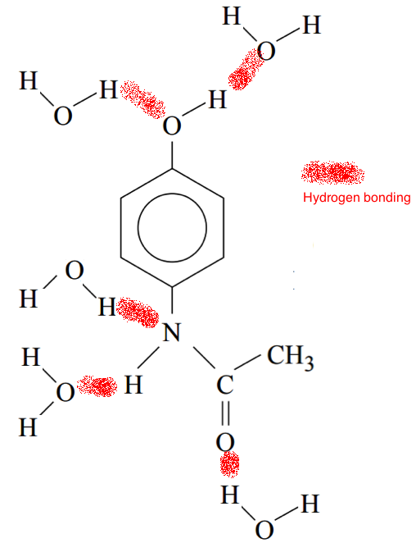

On Earth, water evaporates, forms clouds and falls back to the ground in a process known as the ‘water cycle’.

On Saturn’s moon Titan, where the average temperature is -178 °C, methane (CH4) behaves the same way as water does on Earth, evaporating and raining onto the surface as a liquid.

Using your knowledge of their structure and bonding, explain why water and methane undergo these processes at such different temperatures. (4 marks)

|  |  |
| --- | --- |
| **Answer** | **Cumulative marks** |
| Water has hydrogen bonding | 1 |
| The **strong** hydrogen bonding results in a relatively high boiling point | 1 |
| Methane has dispersion forces only | 1 |
| The **weak** dispersion forces results in a relatively low boiling point | 1 |
|  | **Total: 4 marks** |

Oxalic acid, H2C2O4•2H2O, is a toxic substance found in rhubarb leaves. Solutions of oxalic acid are used in the dying and bleaching industries.   
  
What is the concentration, in mol L-1, of an oxalic acid solution of 10.2 g of oxalic acid dissolved in 200 mL of solution? (2 marks)

|  |  |
| --- | --- |
| **Answer** | **Cumulative marks** |
| n = m/M = 10.2 / 126.068 = 0.080909 mol | 1 |
| c = n/V = 0.080909/0.200 = 0.405 mol/L | 1 |
|  | **Total: 2 marks** |

A group of students wanted to measure the rate of reaction between magnesium and hydrochloric acid at different temperatures. The equation for the reaction is:

Mg + 2 HCℓ 🡪 MgCℓ2 + H2

In order to avoid conflicting results, the students wanted to ensure that they had sufficient acid to react with all of the magnesium.

What volume of 0.1 mol/L acid would be required to completely react with 1 g strips of magnesium?

(3 marks)

|  |  |
| --- | --- |
| **Answer** | **Cumulative marks** |
| n(Mg) = m/M = 1 / 24.31 = 0.0411 mol | 1 |
| n(HCℓ) = 2 x n(Mg) = 0.08227 mol | 1 |
| c = n / V  V = n / C  = 0.08227 / 0.1 = 0.823 L (823 mL) | 1 |
|  | **Total: 3 marks** |

**Question 9**

Caffeine is a stimulant drug that is found in coffee, tea, energy drinks and some soft drinks. The concentration of caffeine in drinks can be determined using HPLC.

Four caffeine standard solutions containing 50 ppm, 100 ppm, 150 ppm and 200 ppm were prepared. 25 μL of each sample was injected into the HPLC column. The peak areas were measured and used to construct the calibration graph below. The chromatograms of the standard solutions each produced a single peak at a retention time of 96 seconds.



25 μL samples of various drinks though to contain caffeine were then separately pass through the HPLC column. The results are summarised below.

|  |  |  |
| --- | --- | --- |
| **Sample** | **Retention time of  major peak (seconds)** | **Peak area of largest peak** |
| Soft drink A | 96 | 12 000 |
| Soft drink B | 32 | 8 500 |

1. What is the concentration, in ppm, of caffeine in soft drink A? (1 mark)

|  |  |
| --- | --- |
| **Answer** | **Cumulative marks** |
| 90 ppm | 1 |
|  | **Total: 1 mark** |



1. What evidence is presented in the chromatogram that supports the conclusion that soft drink B does not contain any caffeine? (1 mark)

|  |  |
| --- | --- |
| **Answer** | **Cumulative marks** |
| No peak at t=96 seconds | 1 |
|  | **Total: 1 mark** |